Networking Business Hub

Networking business hub is the online platform to provide sailors to communicate with other sailors of same stream or various different other streams. The application will have two types of users
1. Guest
2. Member

- Splash Screen
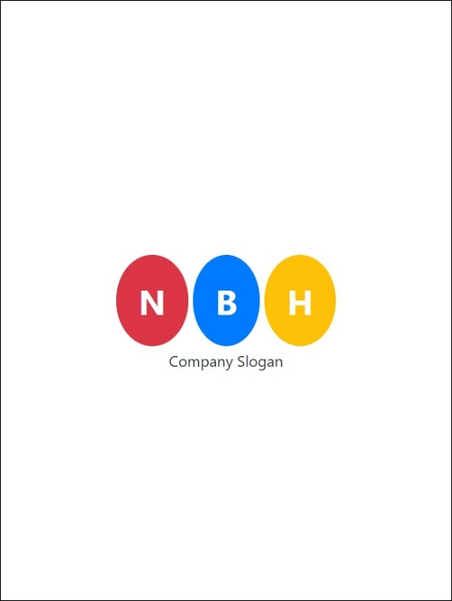
Fig. Splash Screen
Above figure represents the splash screen off the mobile application.
- Once user opens the mobile app splash screen will be shown to user.
- Splash screen time off will be 5 seconds.
- Company logo should be visible on splash screen.
- Add custom animation to company logo.

- Login Screen
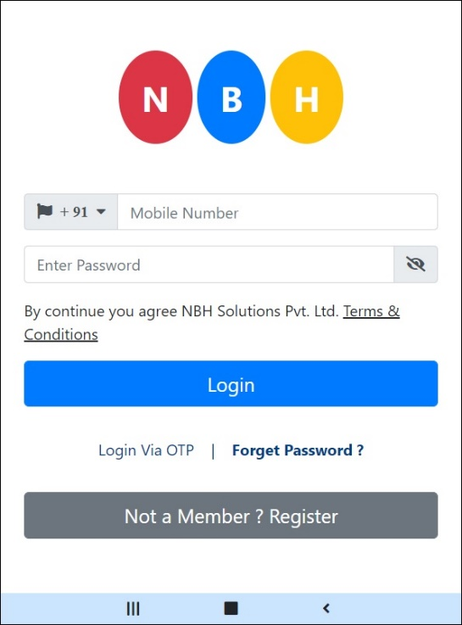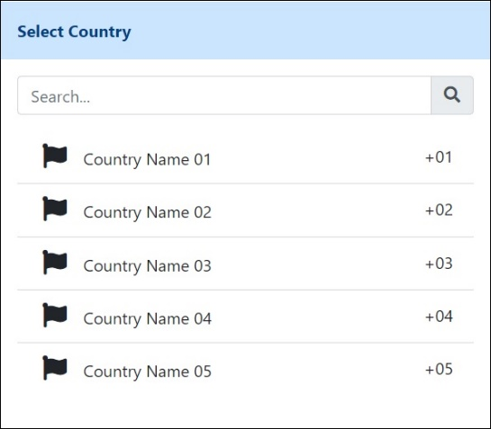
Fig. Login Screen
Above figure is displaying then login of mobile application.
- User can login through username and password or OTP validation generated against the mobile number entered by user.
- When user Clicks on terms and conditions, he/she will be redirected on web browser.
- User can change the country code by clicking on country code drop down. Pop up screen will be shown to user.
- On click of login via OTP link please verify the mobile number entered by the user. Once mobile number is validated user will be redirect to OTP verification screen.
- If user forgot his/her password music and use the forgot password? link.
- If user is new application, he/she can register themselves by using the registration button provided on the login screen.

- Country Code Selection Popup Screen
Fig. Country Code Selection Popup Screen
Above figure is displaying Country Code Popup Window to allow user choose different country code from the country code list
- Flag should be displayed in the list.
- User must be able to search desired code by entering either country name or country code.
- Once Country code is selected by the user Popup up window must closed without the need of user to close it again.

- OTP Verification Screen
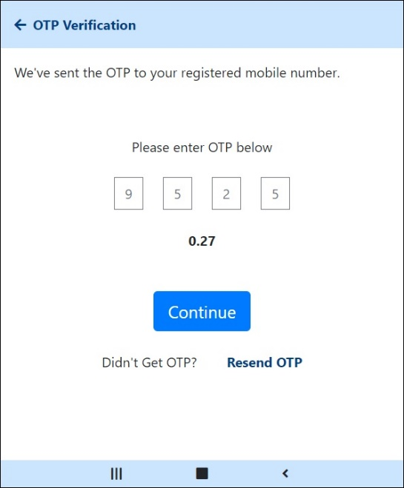
Fig. OTP Verification Screen
Above figure is displaying OTP verification screen for user to verify the system generated OTP received on their device.
- Once OTP code is generated user will be redirected to OTP verification screen.
- Timer will be start once OTP Verification screen open.
- Timeout is of 1 Minute.
- User can navigate back to previous screen by clicking on the back button on the navigation page at the top of the screen.
- If user does not receive OTP code within the time out period user can click on the Resend OTP link to generate another OTP Code.

- Forgot Password Screen
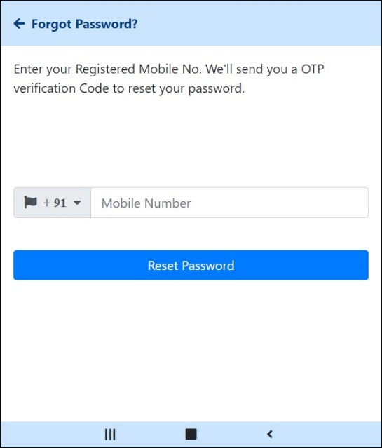
Fig. Forgot Password Screen
Above figure is displaying the Forgot Password Screen once user clicks on the Forgot Password? link present on the Login screen.
- System will ask user for Mobile number conformation.
- User can change the county code from the select county code popup screen open after clicking on County Code drop down list.
- Once Mobile Number is entered by the User Verify the number entered by the user.
- If the Number is verified OPT Code will be generated by the system and it will send to user’s device for conformation.
- User can verify the received OTP Code number by entering it in an OTP Verification screen shown below.
Fig. OTP Verification Screen
- Once OPT is verified successfully user will be redirected to Reset Password screen to change his/her account password.

- Reset Password Screen
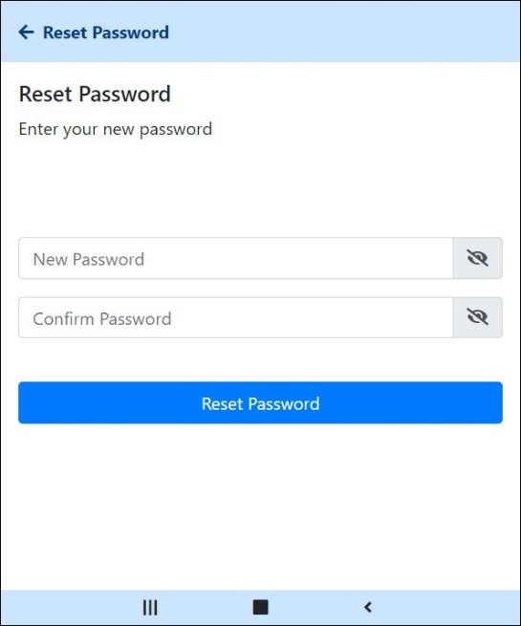
Fig. Reset Password Screen
- Above figure displaying Reset Password Screen is the OPT verification against the Mobile number entered by user in the previous screen is valid.
- User needs to enter New Password and Confirm Password.
- New and Confirm Password should match.
- Once above condition is satisfied user will be forced logout of the system and redirected to login screen again to re-login again.

- Guest Registration
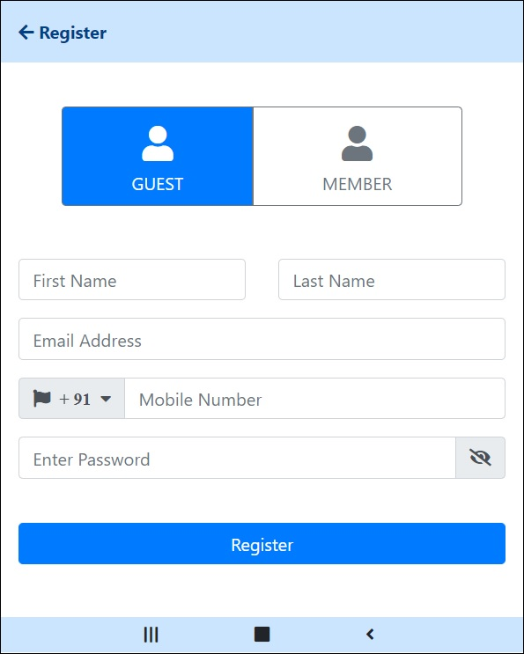
Fig. Guest Registration
Above figure is displaying Guest Registration screen to allow Guest user to register into our application.
- User will select the User type from the list placed at the top of the screen.
- Once User type is selected Popup screen containing user role details for the selected user type will be displayed on the user screen.
- For guest user following fields will be displayed for registration process
  - Fist Name *
  - Last Name *
  - Email *
  - Mobile *
  - Password *
- After filling the details user will click on Register button to complete the registration process.
- Once Registration process is complete display the Registration done successfully message on user screen and redirect user to Guest Dashboard.

- Guest Details Popup Window
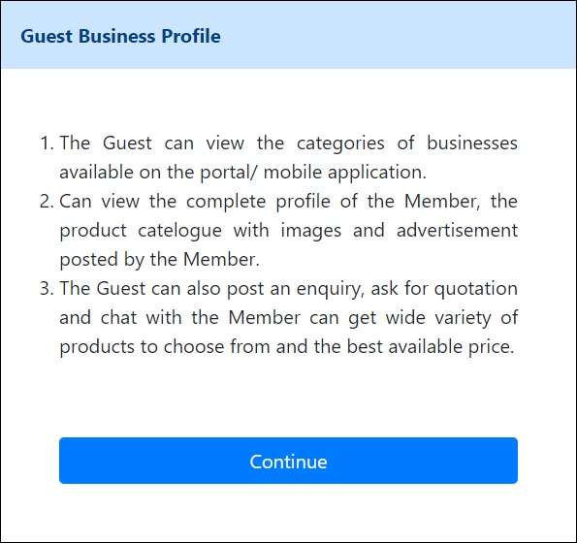
Fig. Guest Details Popup Window
Above figure is displaying Guest Details Popup Window screen which will be open once user select the Guest as user type from the User Type menu on Registration screen.
- Popup screen will display information about the user role assigned to Guest user.
- Window will get closed when user click on the Continue button provide on screen.

- Member Registration
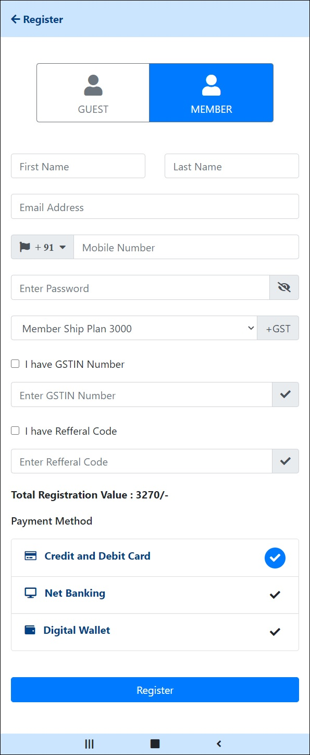
Fig. Member Registration
Above figure is displaying Member Registration screen when user click on the Member User Type from the User Type list on Registration Screen.
- Once user click on the Member user type relevant popup screen will be shown to user. Initially following part will remain hidden on the above screen.
  - I have GSTIN Number Checkbox
  - GSTIN Number Textbox
  - I have Referral Code Checkbox
  - Referral Code Textbox
  - Total Registration Fees
  - Payment Options
- Once user selects the Membership Plan ask user whether he/she have the GSTIN number and or Referral Code.
- Once membership plan is selected by user system will display the registration amount on user registration screen.
- If user have the GSTIN number he/she will check the checkbox for the GSTIN Number and relevant field to enter GSTIN number.
- If user have the Referral Code, he/she will check the checkbox for the Referral Code and relevant field to enter Referral code.
- Entered Referral code will be checked against the database once user enters the Referral code. If Referral code is validated discount amount will be deducted from registration amount shown on screen and new registration amount will be shown to user.
- Following fields will be available for the user registration under Member user type
  - First Name *
  - Last Name *
  - Email *
  - Mobile Number *
  - Password *
  - GSTIN Number [if I have GSTIN Number checkbox is checked]
  - Referral Code [if I have Referral Code checkbox is checked]
  - Payment Method *

- Member Details Popup Window
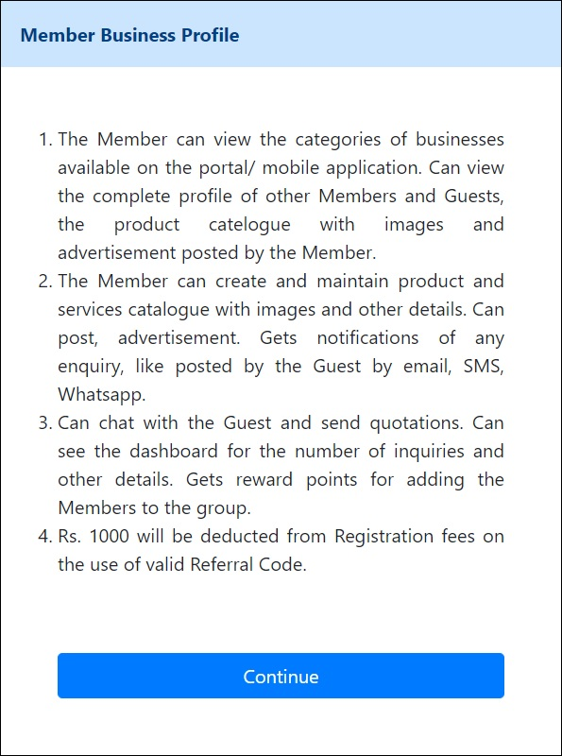
Fig. Member Details Popup Window
Above figure is displaying Member Details Popup Window. Screen will be displayed when user click on the Member User Type from the User Type list on Registration Screen.
- Popup screen will display information about the user role assigned to Member user.
- Window will get closed when user click on the Continue button provide on screen.

- Slider Window
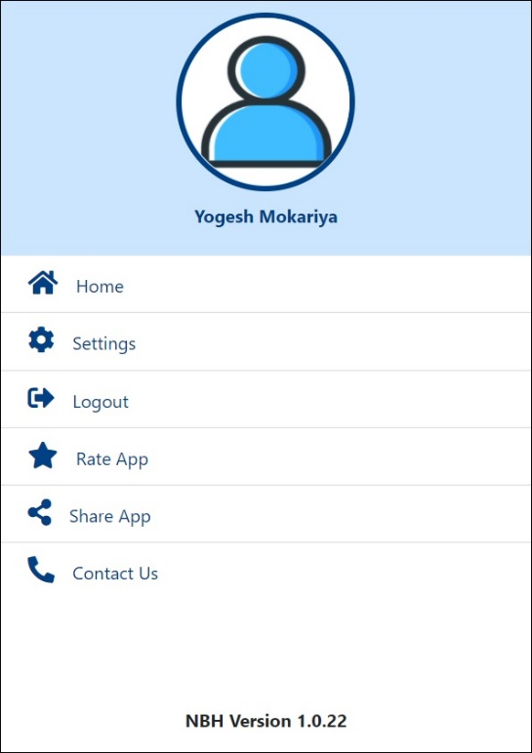
Fig. Slider Window
Above figure is displaying Slider Window on the mobile application. Screen will be made visible when user click on the hamburger menu on the op avigation bar of the application.
The slider will contain the following menu
- User Profile Image is clickable. Once clicked user will be redirected to User Profile Screen.
- Home
Redirect user to Dashboard screen
- Settings
Redirect user to Settings screen
- Logout
Logout from the application
- Rate App
Open Google Play store to input rating for the application
- Share App
Share link of the application along with Referral Code generated for the user.
- Contact Us
Display Contact Us Page

- Settings Page
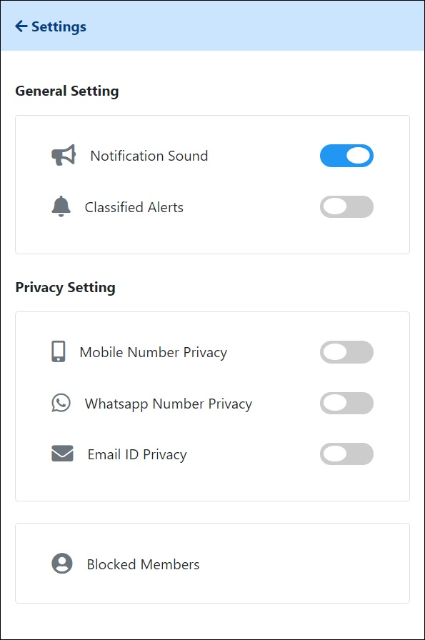
Fig. Settings Page
Above figure is displaying Settings Page of the application.
- The user setting is divided into following two categories.
  - General Setting
  - Privacy Setting
- In general setting user can control the following settings
  - Notification Sound
  - Customized Alerts
- In Privacy Setting user can control the following setting
  - Mobile Number Privacy
  - Alternate Number Privacy
  - Email ID Privacy
- User can also view the list of Blocked Users by clicking the Block User Details link provided at the bottom of the window.

- Blocked User List
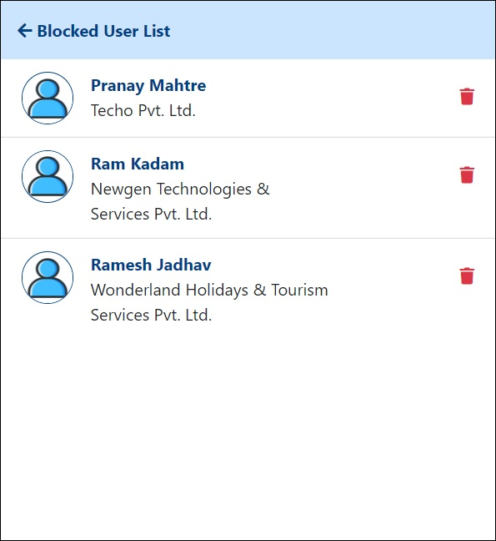
Fig. Blocked User List
Above figure is displaying Blocked User List. Window will appear when user click on the Blocked User Details link provided on the User Settings screen.
- The Blocked user list will contain the Blocked User list displaying following information about the user.
  - User Name
  - Profile Image
  - Company Name
- User can also remove the listed user from Blocked list by clicking on the delete button provided on the right-hand side against each user details.
- Once user clicks on the Delete Blocked user details button following conformation message will appear on user screen.
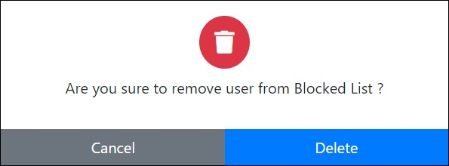
Fig. Block User Delete Conformation Popup Window
- Once user clicks on Delete button on the conformation box selected blocked user will be removed from user block list and user will show updated user block list.

- Contact Us Screen
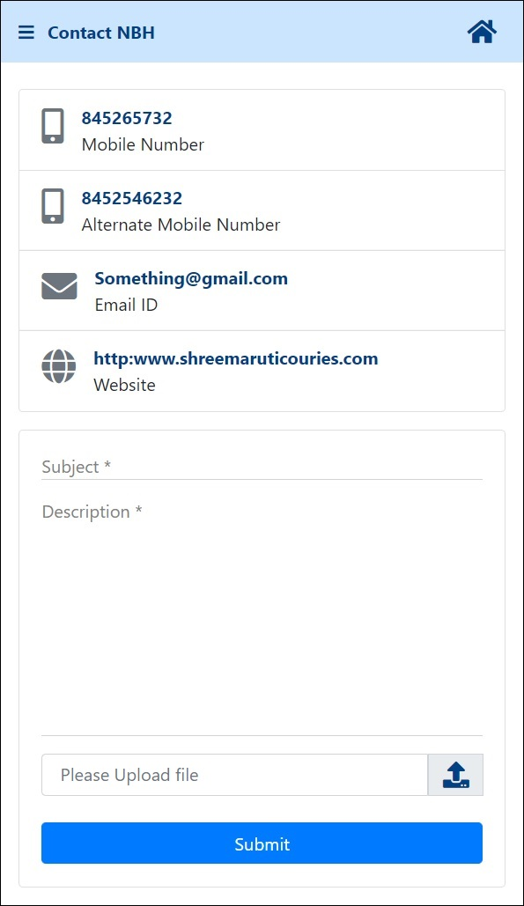
Fig. Contact Us Screen
Above figure displaying the contact details of the mobile application.
- The screen is divided into two sections as follows
  - Contact Links
  - Post User Query
- Contact Link will contain the Company contact details where user can connect with the support staff of the system. Communication link are as follows. When user click on such link appropriate action will be taken.
  - Contact Number – Place a Voice Call on user device
  - Alternate Contact Number – Place a void call on user device
  - Email ID – Draft an Email on the Company Contact Email Address
  - Website – Open the Wb link in the User Browser window
- User can post his/her queries by feeling the details in the query form. User needs to provide following information
  - Query Subject *
  - Query Description *
  - Attached File if any
- Once user clicks on Submit button Successful operation message will be shown to user if operation is done successfully.

- Exit Application Conformation
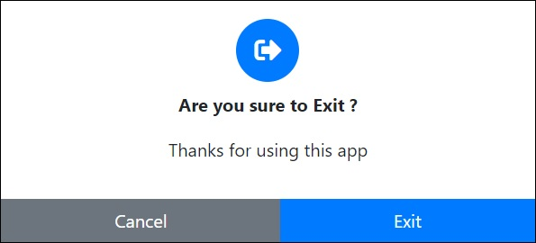
Fig. Exit Application Conformation
User will be asked for conformation before closing the application entirely.

- Member Dashboard
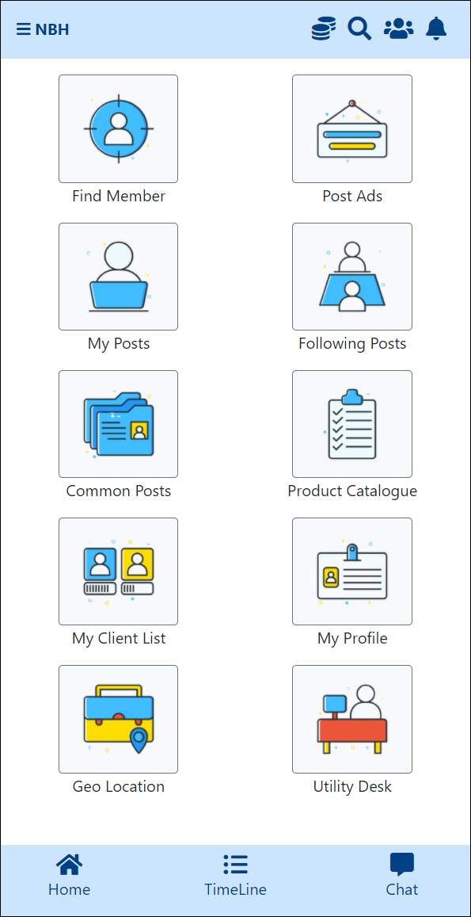
Fig. Member Dashboard
Above figure displaying the dashboard screen for the user type Member.
- Member dashboard screen is divided into three sections as follows
  - Header Section
  - Body
  - Footer Section
- On the Header Section following details will be available
  - On left side there will a hamburger menu to open the slider from the left side of the window.
  - Company Name will be next to it on the left side.
  - On right hand side of the Header user will have following menu options
    - Coins – View Coins earner and redeemed information by user
    - Members – View Member List
    - Search Member – Search Member Using Searching Business Category and Sub Category
    - Notification – Display Notification received by user
- In the Body part of the Dashboard user will have the menu available to him. Member will have the following menu available to him
  - Find Member – Find other members on the platform
  - Create Ad – Create and post advertisement on the common timeline
  - My Posts – View Post uploaded by user
  - Following Post – View Post uploaded by the users whom currently logged user is following
  - Common Posts – View entire application Posts
  - Product Catalogue – View Products Sell by other members
  - My Client List – View List of Client associated with user
  - My Profile – View Profile Details
  - Geo Location – Find Other Members on Map
  - Utility Desk – View Events, Seasonal Greeting, Circulars and etc.
- On the Footer Section User will have the following menu
  - Home – Navigate user to Dashboard screen
  - TimeLine – Navigate user to Common Post
  - Chat – Navigate User to Chat Box

- Guest Dashboard
Fig. Guest Dashboard
- Find Member
Fig. Find Member
- Post Advertisement
Fig. Post Advertisement

- My Posts
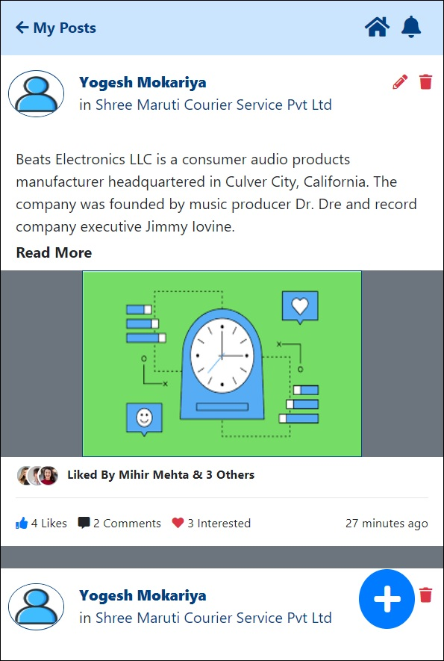
Fin. User Profile – My Post
Above figure is displaying My Posts screen when user click on the My Posts menu on the Member Dashboard screen.
- Timeline should contain following information
  - Member Full Name
  - Company Name
  - Profile Image
  - Post Content
  - Post Image
  - No. of Likes Per Post
  - No. of Comment on Post
  - No. of Interest shown to Post
  - Most recent Like on Post (up to 3 Members)
  - Post Duration with respect to timeline
  - Button to Add new Post (Subject to Business Logic)
  - Button to Edit or Delete Post
- My Posts section will display the posts which are posted by the currently logged in user.
- Posts will be arranged in descending order of the time.
- User Can perform following activities on post.
- Add New Post
- Edit Post
- Delete Post
- Comment on Post
- Post Reply on Comment
- There are some rules set by the client for the Post Management
  - The no. of Post uploaded by the user is restricted to the Membership plan of the user.
  - Depending on the balance no of post the visibility of the Add post button at the bottom-right hand corner of the screen will be managed.
  - Each Post will contain the Post Time, Infinite Text Content with the support of emojis as a post content and a single image while add new post.
  - User can comment on his/her own post as well as other.
  - User cannot Edit or Delete Comments on the uploaded post.
- User can add new Post by clicking on the Add New Post button placed at Bottom right-hand corner of the screen.
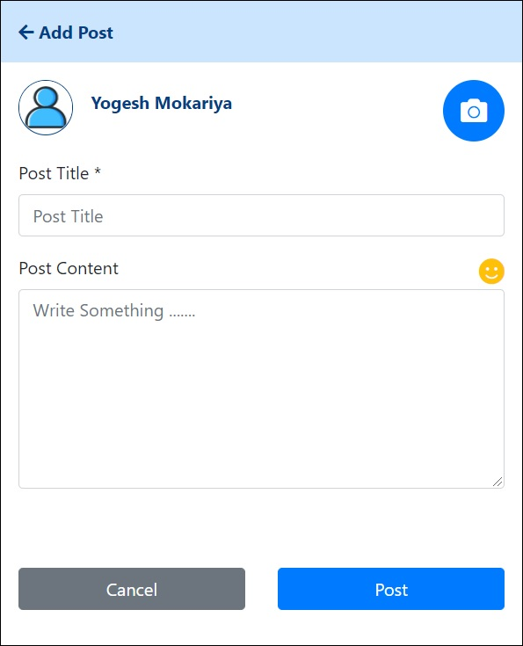
Fig. Add New Post
- User can add the normal Text Content and emojis in the content of the Post. Following details are mandatory while add new post on timeline
- Post Title * – Text explaining what post is about
- Post Content *– Infinite Text with support of emojis
- Post Image *– Single Image per Post
- User can attach only one Image per post. To attach an Image to post user can click on the attach image button.
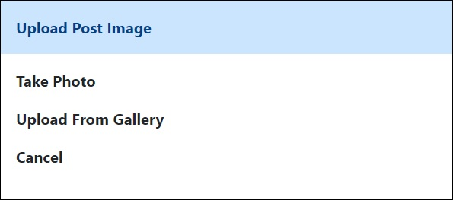
Fig. Upload Image Popup Window
- Popup window will appear on the screen containing following options to upload image.
- Take Photo
- Upload from Gallery
- Cancel
- Each post will have the Edit and Delete button to edit or delete post respectively.
- User can Edit the post by clicking on the Edit button at top right-hand side of each post. User will be redirected to Edit Post screen when user can edit the post content to reupload it on the user timeline.
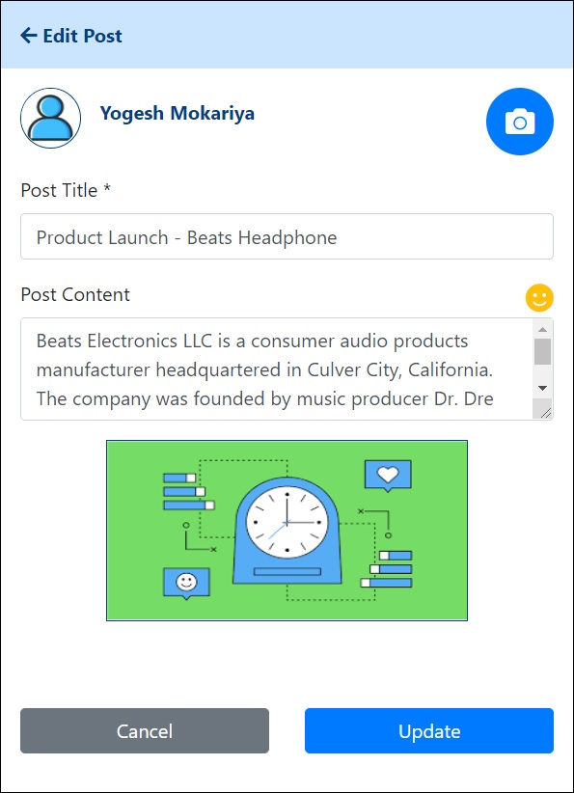
Fig. Edit Post Details
- In the Edit section of the Post user can change the following content of the post
- Post Title *– Text explaining what post is about
- Post Content *– Infinite Text with support of emojis
- Post Image * – Single Image per Post
- To delete the post User can use the Delete button provided beside each Post. Popup window will appear for confirming user before deleting the post as shown in figure.
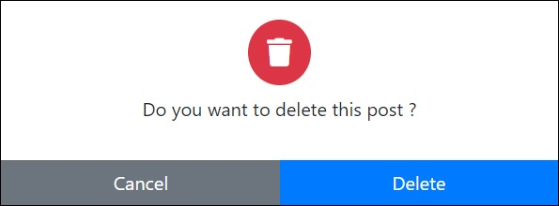
Fig. Delete Post Conformation Popup Window
- The number of post uploaded by the user day is entirely dependent on the business logic of membership plan purchased by the user.
- Once post is deleted. user timeline will be refreshed and deleted post will get removed from the User Timeline.
- User can also post comments on the post posted on timeline. Use will click on the Comment icon for the selected post and Comment window will appear on the user’s mobile screen as shown in figure.
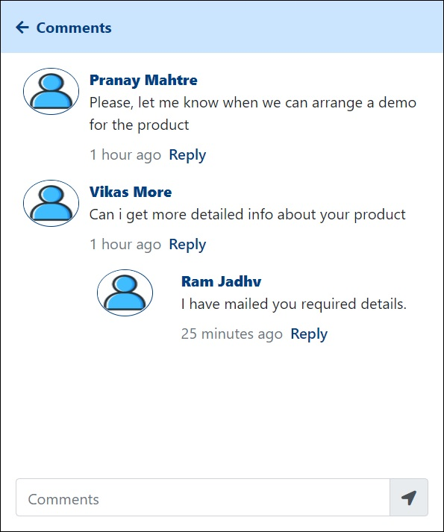
Fig. Add Comment on User Post
- Comment box is placed at the bottom of the screen. Comments will contain only text contain and emojis.
- User can view the previous comment of other users added on the post.
- If there are no previous comments present for the post the window will remain blank displaying message as “Be the first to comment on post”.
- Also, user can reply to Comments posted by another user. Each comment posted by user will have the following information
  - Profile Image of the User
  - Comment Content
  - Comment Posted on
  - Link to Reply on Comment
- User can click on the link provided for each comment to reply on it.
- Popup window will appear on user screen to post a reply on the comment as shown in the following figure.
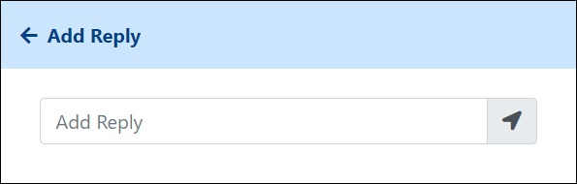
Fig. Post Reply on Comment
- User can enter his/her reply and post the reply on the selected comment. Comment screen will get refreshed once the user updates his/her reply on the screen to display the reply accordingly.
- User can go back to previous screen without adding reply to comment by pressing the back button on the top left side of the popup window.

- Following Posts
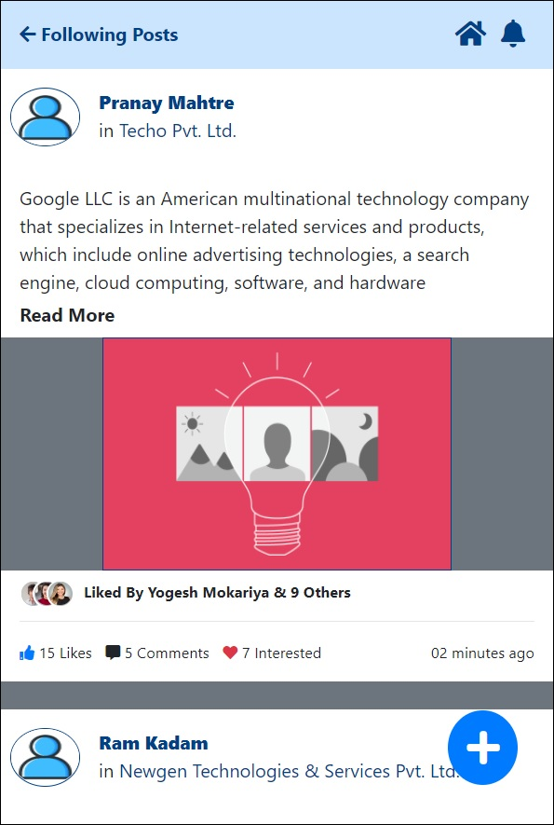
Fin. Following Post
Above figure is displaying Following Posts screen when user click on the Following Posts menu on the Member Dashboard screen.
- Timeline should contain following information
  - Member Full Name
  - Company Name
  - Profile Image
  - Post Content
  - Post Image
  - No. of Likes Per Post
  - No. of Comment on Post
  - No. of Interest shown to Post
  - Most recent Like on Post (up to 3 Members)
  - Post Duration with respect to timeline
  - Button to Add new Post (Subject to Business Logic)
- Following Posts section will display the posts which are posted by the member to user is currently following.
- Posts will be arranged in descending order of the time.
- User Can perform following activities on post.
- Add New Post
- Comment on Post
- Post Reply on Comment
- Visit another User Timeline clicking on User Profile Image

- There are some rules set by the client for the Post Management
  - The no. of Post uploaded by the user is restricted to the Membership plan of the user.
  - Depending on the balance no of post the visibility of the Add post button at the bottom-right hand corner of the screen will be managed.
  - Each Post will contain the Post Time, Infinite Text Content with the support of emojis as a post content and a single image while add new post.
  - User can comment on his/her own post as well as other.
  - User cannot Edit or Delete Comments on the uploaded post.
- User can add new Post by clicking on the Add New Post button placed at Bottom right-hand corner of the screen.
Fig. Add New Post
- User can add the normal Text Content and emojis in the content of the Post. Following details are mandatory while add new post on timeline
- Post Title * – Text explaining what post is about
- Post Content *– Infinite Text with support of emojis
- Post Image *– Single Image per Post
- User can attach only one Image per post. To attach an Image to post user can click on the attach image button.
Fig. Upload Image Popup Window
- Popup window will appear on the screen containing following options to upload image.
- Take Photo
- Upload from Gallery
- Cancel
- The number of post uploaded by the user day is entirely dependent on the business logic of membership plan purchased by the user.
- User can also post comments on the post posted on timeline. Use will click on the Comment icon for the selected post and Comment window will appear on the user’s mobile screen as shown in figure.
Fig. Add Comment on User Post
- Comment box is placed at the bottom of the screen. Comments will contain only text contain and emojis.
- User can view the previous comment of other users added on the post.
- If there are no previous comments present for the post the window will remain blank displaying message as “Be the first to comment on post”.
- Also, user can reply to Comments posted by another user. Each comment posted by user will have the following information
  - Profile Image of the User
  - Comment Content
  - Comment Posted on
  - Link to Reply on Comment
- User can click on the link provided for each comment to reply on it. Popup window will appear on user screen to post a reply on the comment as shown in the following figure.
Fig. Post Reply on Comment
- User can enter his/her reply and post the reply on the selected comment. Comment screen will get refreshed once the user updates his/her reply on the screen to display the reply accordingly.
- User can go back to previous screen without adding reply to comment by pressing the back button on the top left side of the popup window.
- User can also view the other member timeline by clicking on the User Profile Image icon on the Following timeline. Once user click on the User Profile Image user will be redirected to the selected user Timeline screen.
- The User Timeline details is shown in the following figure
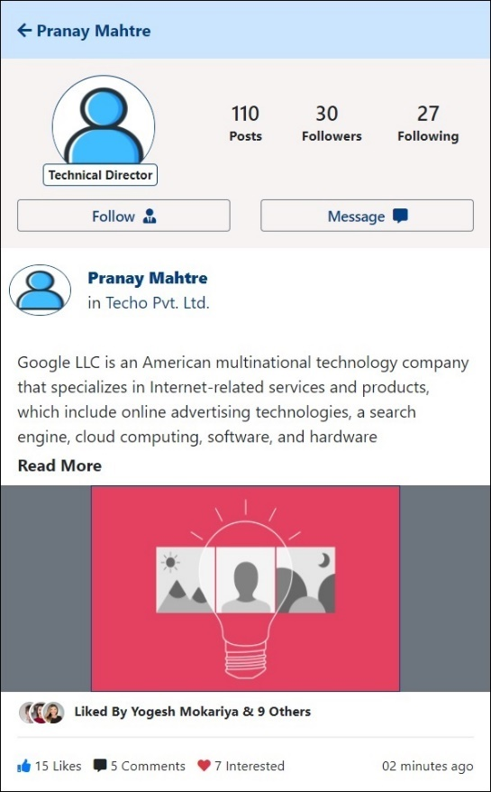
Fig. User Timeline Detailed View
- User can view following details on member timeline as follows
- No. of uploaded by the member
- No. of other users following the selected member
- No. of user followed by member
- If selected member is not followed by current logged in user system will show the Follow button to follow selected member otherwise system will show the Unfollow button.
- On click of the Message button user will be redirected messaging app of the user mobile device sending message to the selected member’s mobile number.

- Common Posts
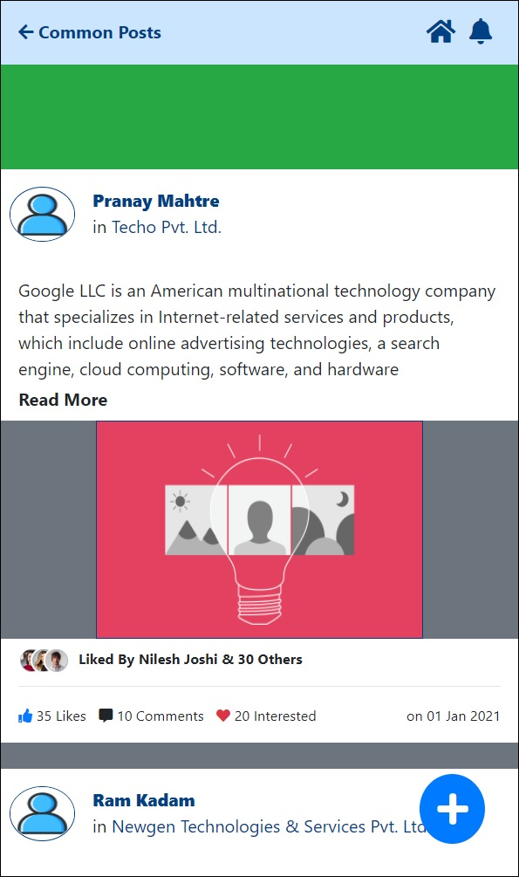
Fin. Common Post
Above figure is displaying Common Posts screen when user click on the Common Posts menu on the Member Dashboard screen.
- Timeline should contain following information
  - Advertisements on top of the screen with marquee effect
  - Member Full Name
  - Company Name
  - Profile Image
  - Post Content
  - Post Image
  - No. of Likes Per Post
  - No. of Comment on Post
  - No. of Interest shown to Post
  - Most recent Like on Post (up to 3 Members)
  - Post Duration with respect to timeline
  - Button to Add new Post (Subject to Business Logic)
- Note the green section at the top half of the screen is where the advertisement will take place. Advertisement will be continually visible to user. Adds will be arranged in marquee effect such that they will come one after another. There will be only 5 ads per day will be shown to user. Adds will be displayed only on Common Post timeline.
- Common Posts section will display the posts posted by all the members who are using the NBH application.
- Posts will be arranged in descending order of the time.
- User Can perform following activities on Common post.
- Add New Post
- Comment on Post
- Post Reply on Comment
- Visit another User Timeline clicking on User Profile Image
- View Advertisements
- There are some rules set by the client for the Post Management
  - The no. of Post uploaded by the user is restricted to the Membership plan of the user.
  - Depending on the balance no of post the visibility of the Add post button at the bottom-right hand corner of the screen will be managed.
  - Each Post will contain the Post Time, Infinite Text Content with the support of emojis as a post content and a single image while add new post.
  - User can comment on his/her own post as well as other.
  - User cannot Edit or Delete Comments on the uploaded post.
- User can add new Post by clicking on the Add New Post button placed at Bottom right-hand corner of the screen.
Fig. Add New Post
- User can add the normal Text Content and emojis in the content of the Post. Following details are mandatory while add new post on timeline
- Post Title * – Text explaining what post is about
- Post Content *– Infinite Text with support of emojis
- Post Image *– Single Image per Post
- User can attach only one Image per post. To attach an Image to post user can click on the attach image button.
Fig. Upload Image Popup Window
- Popup window will appear on the screen containing following options to upload image.
- Take Photo
- Upload from Gallery
- Cancel
- The number of post uploaded by the user day is entirely dependent on the business logic of membership plan purchased by the user.
- User can also post comments on the post posted on timeline. Use will click on the Comment icon for the selected post and Comment window will appear on the user’s mobile screen as shown in figure.
Fig. Add Comment on User Post
- Comment box is placed at the bottom of the screen. Comments will contain only text contain and emojis.
- User can view the previous comment of other users added on the post.
- If there are no previous comments present for the post the window will remain blank displaying message as “Be the first to comment on post”.
- Also, user can reply to Comments posted by another user. Each comment posted by user will have the following information
  - Profile Image of the User
  - Comment Content
  - Comment Posted on
  - Link to Reply on Comment
- User can click on the link provided for each comment to reply on it. Popup window will appear on user screen to post a reply on the comment as shown in the following figure.
Fig. Post Reply on Comment
- User can enter his/her reply and post the reply on the selected comment. Comment screen will get refreshed once the user updates his/her reply on the screen to display the reply accordingly.
- User can go back to previous screen without adding reply to comment by pressing the back button on the top left side of the popup window.
- User can also view the other member timeline by clicking on the User Profile Image icon on the Following timeline. Once user click on the User Profile Image user will be redirected to the selected user Timeline screen.
- The User Timeline details is shown in the following figure
Fig. User Timeline Detailed View
- User can view following details on member timeline as follows
- No. of uploaded by the member
- No. of other users following the selected member
- No. of user followed by member
- If selected member is not followed by current logged in user system will show the Follow button to follow selected member otherwise system will show the Unfollow button.
- On click of the Message button user will be redirected messaging app of the user mobile device sending message to the selected member’s mobile number.

- Product Catalogue
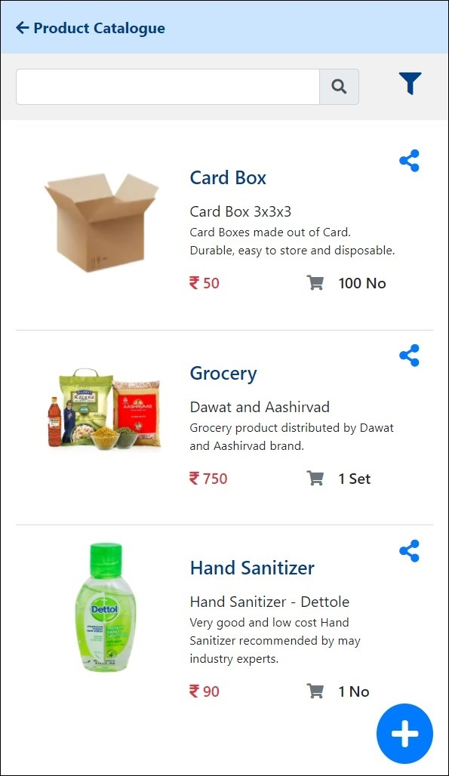
Fig. View Product Catalogue
Above figure is displaying Product Catalogue screen when user click on the Product catalogue menu on the User Dashboard screen.
- User can view product details in the product catalogue screen. Following details will be shown about the products in product catalogue
- Product Image
- Product Name
- Product Description
- Other Information
- Product Price
- Minimum Order Qty
- Product Share Button to Share Product info with others
- User can perform following activities in the product catalogue
- View Product Detailed View
- Search Product Details
- Add New Product
- Share Individual Product
- To view detailed product information user can click on the Product name to navigate on the details view of product information.
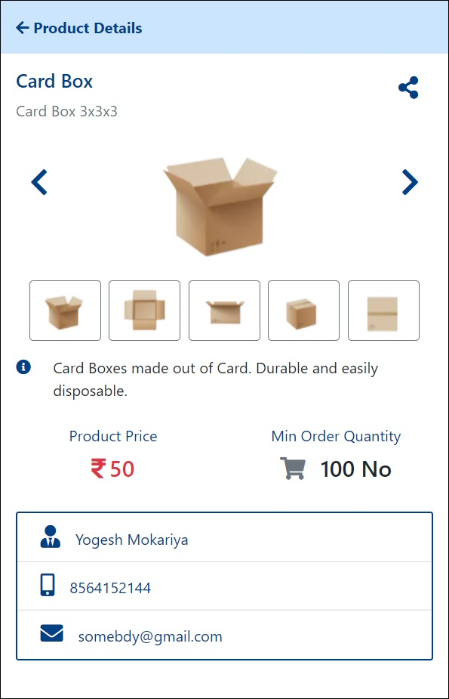
Fig. Product Detailed View
- The detailed product detailed view let user know about the in depth. The detailed view of the of product display the following information.
- User can view different product images by using the image slider provided on the screen. For better navigation through images user can user the next and previous button on slider.
- In detailed view User can also view the supplier details for the selected product. Following supplier details will be shown to user
- Supplier Name
- Supplier Mobil No
- Supplier Email Address
- User can search the product detail by entering the product name in the search textbox placed at the top of the screen.
- If user wants in depth search for the product details user can user Advanced Product search facility by clicking the filter menu on the right-hand side of the search textbox.
- A popup winnow will appear on user screen allowing user to user multiple filers to search and view product details. Advance Product search have following filters.
- Product Name
- Keywords
- Business Category
- Business Sub Category
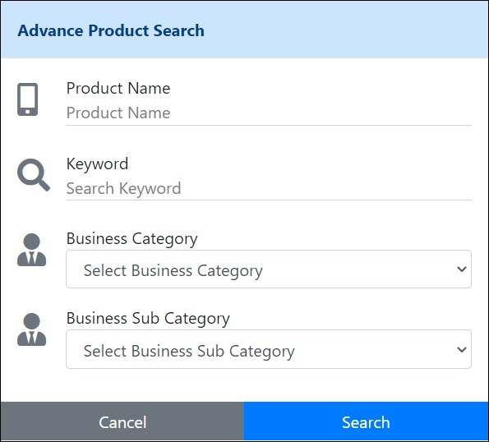
Fig. Advance Product Search
- User can also add new Product in his/her product catalogue by clicking on Add Product Details button the bottom right-hand corner of the screen as shown in the following figure.
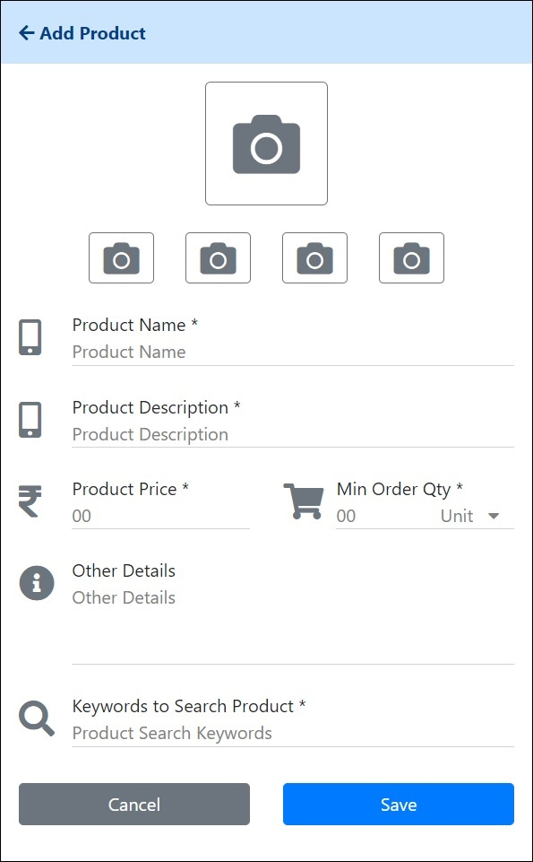
Fig. Add Product Details
- User will be redirected to Add Product screen. User will be entering the following information to Add new Product to product catalogue.
- Product Name *
- Product Description *
- Product Price *
- Product Minimum Quantity and Unit *
- Other Information
- Search Keyword for product *
- Product Primary Image *
- Product secondary Images [Max 04]
- The primary image is mandatory as it will displayed on product catalogue screen and share product details screen. The primary image is placed at top of the screen. The four images at the bottom of it are secondary product images and thus not mandatory.
- User can Share the product details by clicking on the individua share button provided for each product. When user clicks on the individual product share button, he/she will be redirected to Product Share Details screen as shown in following figure
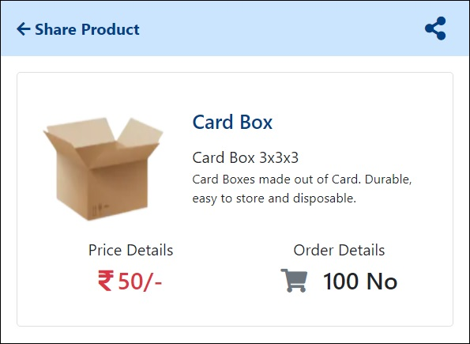
Fig. Product Details Share Screen

- Member Profile
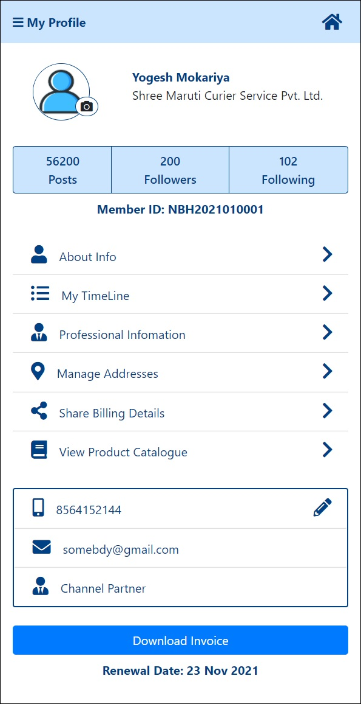
Fig. Member Profile
Above figure displaying Member Profile screen.
- Member Profile is divided into five sections
  - General Details
  - User Stats Details
  - User Information Links
  - User Contact Details
  - Download Invoice
- In general details section user will have the following details
  - User Profile Image
  - User Full Name
  - Company Name
- User can change Profile Image by Clicking on Camera icon provided near User Profile Image.
- In User Stats Section User will have the following details to view
  - No. of Post uploaded by user
  - No. of members user is following
  - No. of members who as following the user
- User Information Link section will contain the link of different user related details menu from where user will be redirected to different pages.
  - About Info – Navigate User to Personal Profile Info screen
  - My Timeline – Navigate User to My Timeline screen
  - Professional Info – Navigate User to Professional Profile Info screen
  - Manage Address – Navigate User to Manage Company Address screen
  - Share Billing Details – Navigate User to Billing Info screen
  - View Product Catalogue – Navigate User to Product catalogue screen
- In Contact Section User will show his/her primary contact information as follows
  - User Mobile Number
  - User Email Address
  - User Designation
- User can edit the Mobile number by clicking on the Edit button provided in the User contact details section.
- In Download Invoice section we have provided the Download Invoice Button to user. The pdf file containing invoice information will be downloaded on the user device once clicked on Download Invoice button.
- At the bottom of the screen system will display the Renewal date of the Membership for the logged in user.

- Guest Profile
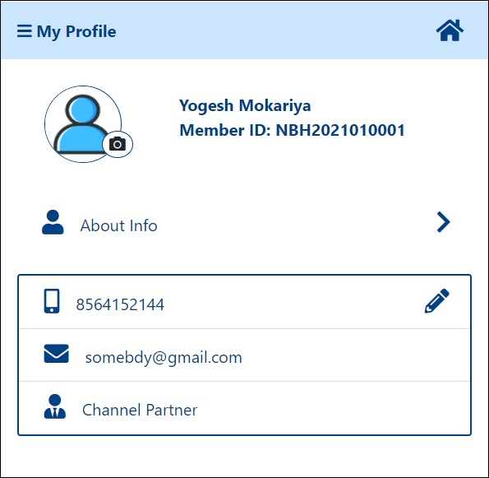
Fig. Guest Profile
Above figure is displaying the Guest Profile screen.
- Guest Profile is divided into three sections
  - General Details
  - User Information Links
  - User Contact Details
- In general details section user will have the following details
  - User Profile Image
  - User Full Name
  - Company Name
- User can change Profile Image by Clicking on Camera icon provided near User Profile Image.
- User Information Link section will contain the link of different user related details menu from where user will be redirected to different pages.
  - About Info – Navigate User to Personal Profile Info screen
- In Contact Section User will show his/her primary contact information as follows
  - User Mobile Number
  - User Email Address
  - User Designation
- User can edit the Mobile number by clicking on the Edit button provided in the User contact details section.

- Change Profile Image
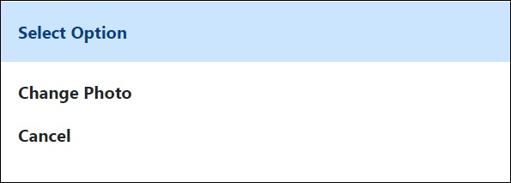
Fig, Change Profile Image
Above figure displaying Change Profile Image screen.
- User can change the Profile image by click on the camera icon provide at the right-bottom hand side corner of the profile image on User Profile Screen.
- Popup window should appear on user screen once we click on the camera icon near Profile Image.
- Display following two options in the popup windows
    - Change Photo
    - Cancel

- Change Mobile Number
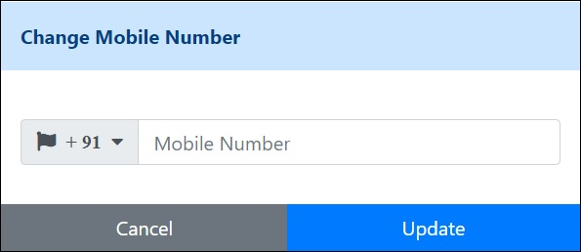
Fig. Change Mobile Number
Above figure displaying Change Mobile Number screen.
- User can Edit the contact number by clicking on the edit button on the User Profile screen in User contact details section.
- Popup menu will appear on the user mobile.
- User will enter the Mobile number in the Textbox appear on the Popup window.
- User can change the Country Code of the mobile number by clicking on the County Code drop down. Country Code Selection Popup window will be displayed on user screen.
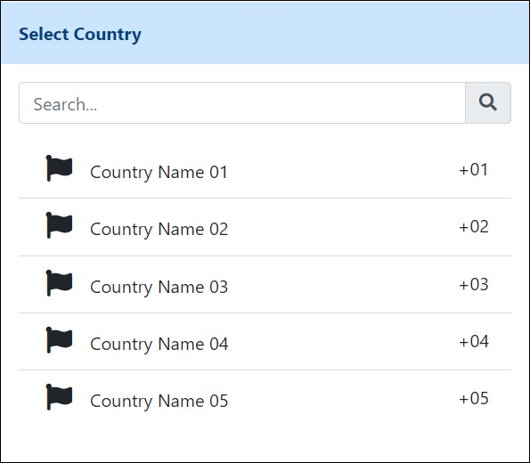
Fig. County Code Selection Popup Screen
- Validate the Mobile Number entered by user.
- Once OTP is generated a send to user device user will be navigate to OTP verification screen for mobile number change. Mobile number entered by user in previous screen will get copied over in this screen.
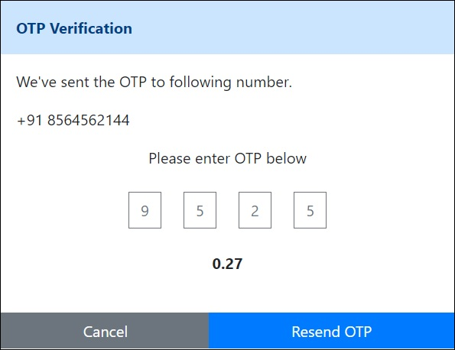
Fig. OTP Verification for Mobile Number Change
- Timer will be start once OTP Verification screen open.
- Timeout is of 1 Minute.
- User can navigate back to previous screen by clicking on the back button on the navigation page at the top of the screen.
- If user does not receive OTP code within the time out period user can click on the Resend OTP link to generate another OTP Code.

- View Followers List
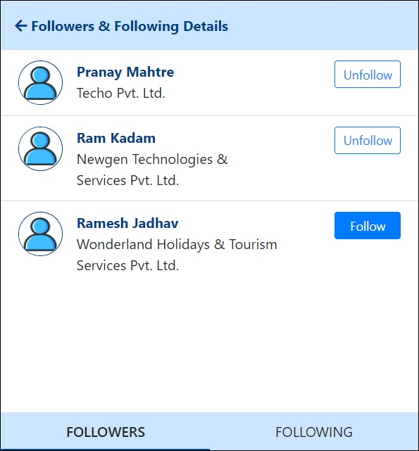
Fig. User Followers List
Above figure is displaying the list of members following the logged in user.
- Users follower list will appear on user mobile screen when user click on the follower’s number in the User Profile screen in User Stat details section.
- Follower name list must order by follower name.
- List should contain following details
  - Profile Image
  - Full Name
  - Company Name
  - Follow and Unfollow button at right hand side of each Member details
- At the bottom of the screen will provide navigation pane to switch between Followers List and Following List.
- Each list item containing Follower details will have a Follow back or Unfollow button to perform the Follow or Unfollow activity.
- Once user is unfollowed the button state for the selected user should be changed back to Follow.

- View Following List
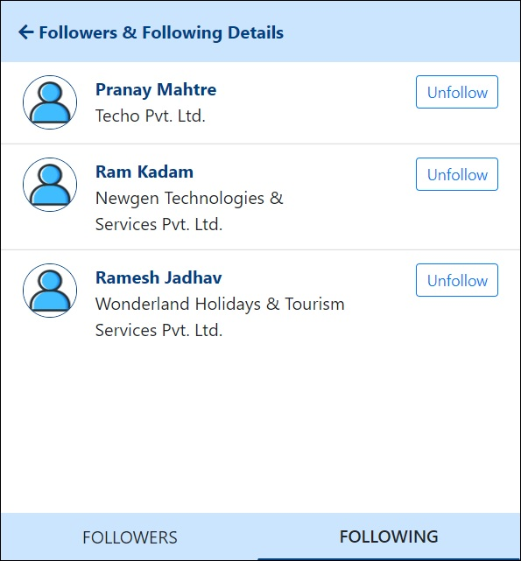
Fig. User Following List
Above figure is displaying list of member user is following on the screen.
- Users following list appear on user mobile screen when user click on the following’s number in the User Profile screen in User stat details screen.
- Following name list must order by following name
- List should contain following details
  - Profile Image
  - Full Name
  - Company Name
  - Unfollow button too Unfollow following user
- At the bottom of the screen will provide navigation pane to switch between Followers List and Following List
- Each list item containing Following details will have a Unfollow button to perform the Unfollow activity
- Once user is unfollowed his/her name should be disappearing from the Followers list on the screen.

- User Profile - About Info
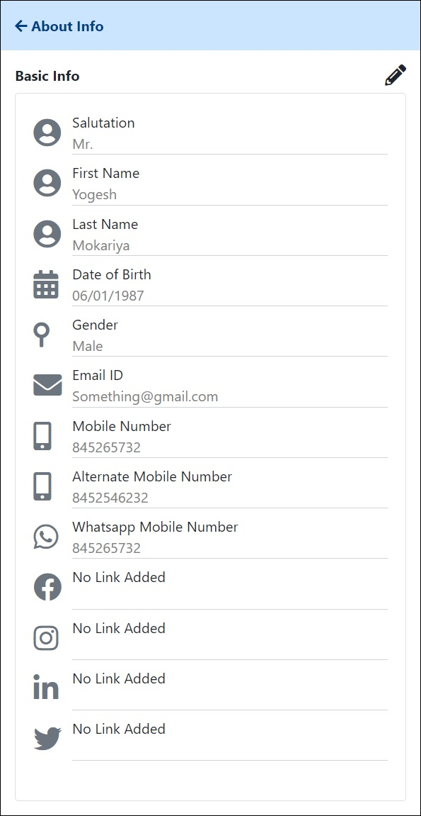
Fig. About Info Read-only View
Above figure displaying the About Info of the User in Read only view.
- User can view and edit his/her Personal information in the User Personal Profile section of the User Profile Screen.
- When user click on About Info system will display the User Personal Profile screen on user mobile screen.
- Display the following details in User Personal Profile
  - Salutation
  - First Name *
  - Last Name *
  - Date of Birth
  - Gender
  - Email ID *
  - Mobile Number *
  - Alternative Mobile Number
  - WhatsApp Mobile Number
  - Facebook Link
  - Instagram Link
  - LinkedIn Link
  - Twitter Link
- Edit Icon should be provided on the right top corner of the window to switch the view to edit mode to make changes in the User Personal Profile.
- When user click on the Edit menu on the screen Edit view will be user for user to edit and update the User Personal Information.
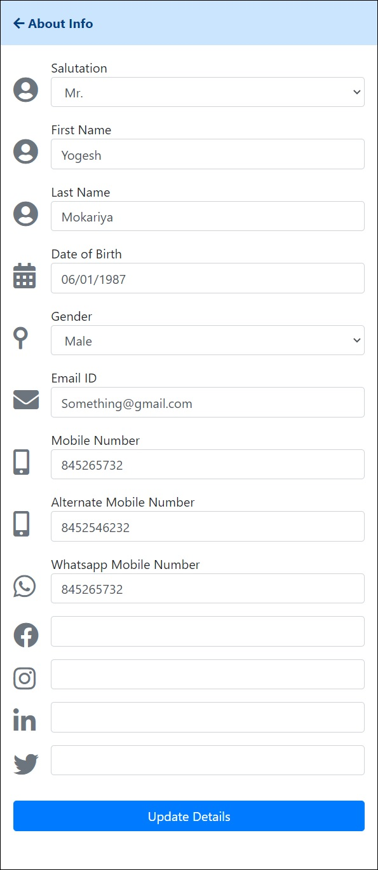
Fig. User About Info Edit View

- User Profile – My Timeline
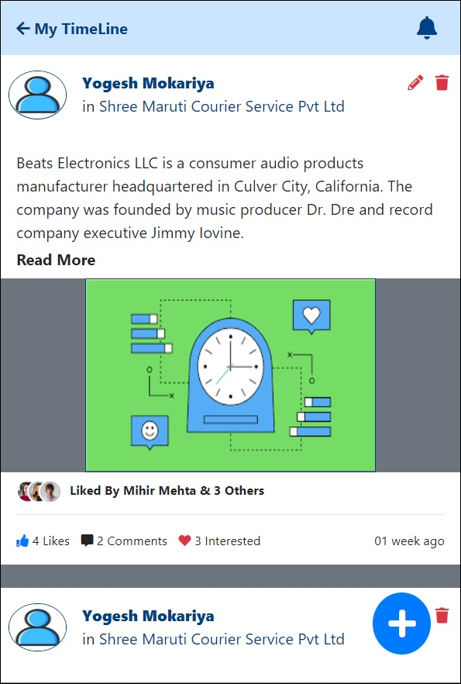
Fin. User Profile – My Timeline
Above figure is displaying User Profile – My Timeline screen when user click on the My Timeline link from the User Details Info Link Section from the User Profile screen.
- Timeline should contain following information
  - Member Full Name
  - Company Name
  - Profile Image
  - Post Content
  - Post Image
  - No. of Likes Per Post
  - No. of Comment on Post
  - No. of Interest shown to Post
  - Most recent Like on Post (up to 3 Members)
  - Post Duration with respect to timeline
  - Button to Add new Post (Subject to Business Logic)
  - Button to Edit or Delete Post
- My Timeline section will display the posts which are posted by the currently logged in user.
- Timeline will be arranged in descending order of the time.
- User Can perform following activities on post.
- Add New Post
- Edit Post
- Delete Post
- Comment on Post
- Post Reply on Comment
- There are some rules set by the client for the Post Management
  - The no. of Post uploaded by the user is restricted to the Membership plan of the user.
  - Depending on the balance no of post the visibility of the Add post button at the bottom-right hand corner of the screen will be managed.
  - Each Post will contain the Post Time, Infinite Text Content with the support of emojis as a post content and a single image while add new post.
  - User can comment on his/her own post as well as other.
  - User cannot Edit or Delete Comments on the uploaded post.
- User can add new Post by clicking on the Add New Post button placed at Bottom right-hand corner of the screen.
Fig. Add New Post
- User can add the normal Text Content and emojis in the content of the Post. Following details are mandatory while add new post on timeline
- Post Title * – Text explaining what post is about
- Post Content *– Infinite Text with support of emojis
- Post Image *– Single Image per Post
- User can attach only one Image per post. To attach an Image to post user can click on the attach image button.
Fig. Upload Image Popup Window
- Popup window will appear on the screen containing following options to upload image.
- Take Photo
- Upload from Gallery
- Cancel
- Each post will have the Edit and Delete button to edit or delete post respectively.
- User can Edit the post by clicking on the Edit button at top right-hand side of each post. User will be redirected to Edit Post screen when user can edit the post content to reupload it on the user timeline.
Fig. Edit Post Details
- In the Edit section of the Post user can change the following content of the post
- Post Title *– Text explaining what post is about
- Post Content *– Infinite Text with support of emojis
- Post Image * – Single Image per Post
- To delete the post User can use the Delete button provided beside each Post. Popup window will appear for confirming user before deleting the post as shown in figure.
Fig. Delete Post Conformation Popup Window
- The number of post uploaded by the user day is entirely dependent on the business logic of membership plan purchased by the user.
- Once post is deleted. user timeline will be refreshed and deleted post will get removed from the User Timeline.
- User can also post comments on the post posted on timeline. Use will click on the Comment icon for the selected post and Comment window will appear on the user’s mobile screen as shown in figure.
Fig. Add Comment on User Post
- Comment box is placed at the bottom of the screen. Comments will contain only text contain and emojis.
- User can view the previous comment of other users added on the post.
- If there are no previous comments present for the post the window will remain blank displaying message as “Be the first to comment on post”.
- Also, user can reply to Comments posted by another user. Each comment posted by user will have the following information
  - Profile Image of the User
  - Comment Content
  - Comment Posted on
  - Link to Reply on Comment
- User can click on the link provided for each comment to reply on it.
- Popup window will appear on user screen to post a reply on the comment as shown in the following figure.
Fig. Post Reply on Comment
- User an enter his/her reply and post the reply on the selected comment. Comment screen will get refreshed once the user updates his/her reply o n the screen to display the reply accordingly.
- User can go back to previous screen without adding reply to comment by pressing the back button on the top left side of the popup window.

- User Profile – Professional Information
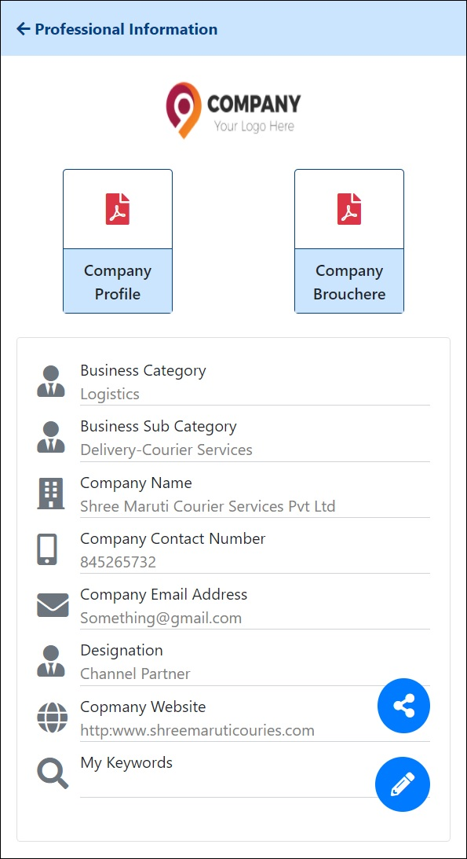
Fig. User Professional Profile
Above figure is displaying User Professional Profile screen when user click on the View Professional details link in the User detail Info Links section of the User Profile screen.
- User professional profile can contain the following information:
  - Profile File
  - Boucher File
  - Company Logo
  - Category Name *
  - Sub Category Name *
  - Company Name *
  - Company Contact Number *
  - Company Email Address *
  - Company Website
  - Designation
  - Search Keywords *
  - About Business
  - Products and Services offered
- User can share and Edit the Professional information. To edit the professional details user can click on the edit button to open the Edit view of the Professional profile.
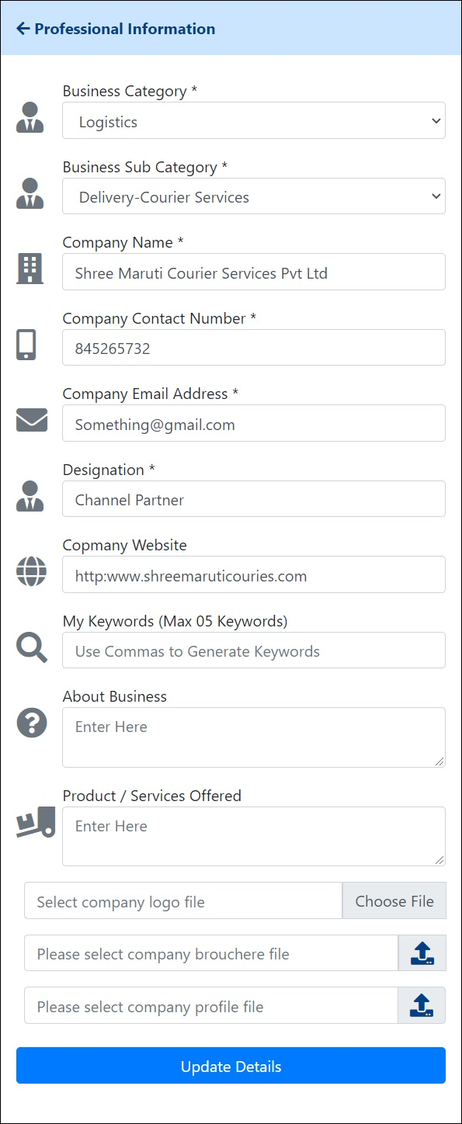
Fig. User Professional Profile Edit View
- Business Category and Business Sub Category will be etched from database. Business Category and Business Sub Category are cascading drop down list where Business Sub Category is depended on Business Category drop down.
- User can Company Logo. Company logo must be image file.
- Search keyword are comma separated. User can add up to 5 search keywords.
- User can also upload the Company Brochure file and company Profile file. Following are restrictions while uploading file in professional information
- Company Profile File – File must be in pdf format
- Company Brochure File – File must be in pdf format
- Company Logo File – File must be in image format
- To share the professional profile user can user the Share button. User professional profile will be shared on the timeline.
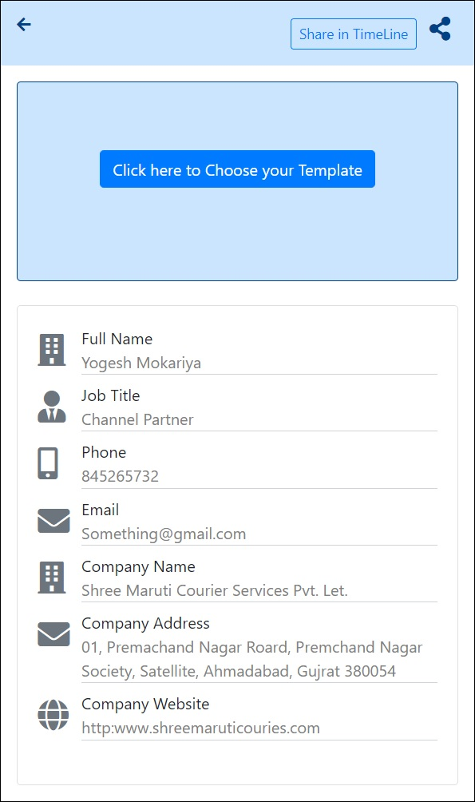
Fig. User Professional Profile Share View
- User can share the Professional profile by clicking on the Share button on the right-top of the screen. Once clicked application should display the all-possible sharing mediums for the User Professional profile.

- User Profile – Share Billing Details
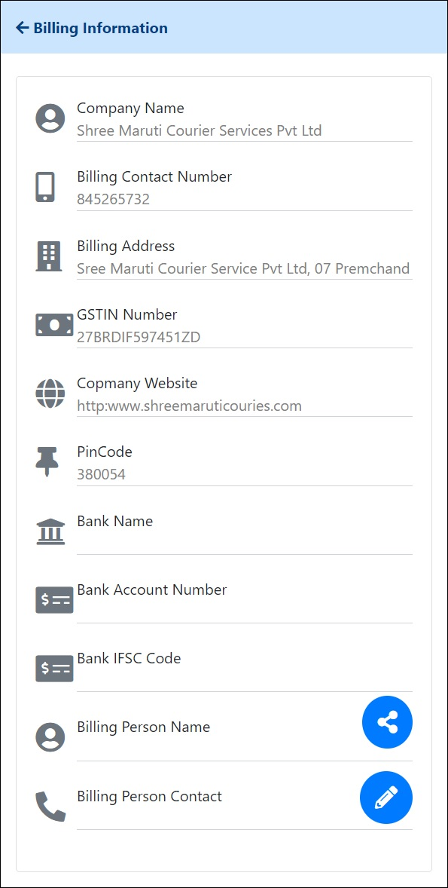
Fig. Billing Information Details
Above figure is showing the Billing Information details of the member when user click on the Share Billing Information link in the User Information Link Section on the User Profile screen.
- User Billing information contains following fields:
  - Company Name *
  - Billing Contact Number *
  - Billing Address
  - GSTIN Number *
  - Company Website
  - Pin Code *
  - Bank Name *
  - Bank Account Number *
  - Bank IFSC Code *
  - Billing Person Name *
  - Billing Person Number *
- User can share and Edit the Billing information by using the Share and Edit menu provided by the system.
- GSTIN Number in the billing information ill be fetched from registration details if user has selected the I have GSTIN Number and provided the GSTIN Number while registration.
- To edit billing information user can click on the Edit Billing Information button provided on the screen. User will be redirected to the Billing information edit view to edit and updated the Billing information.
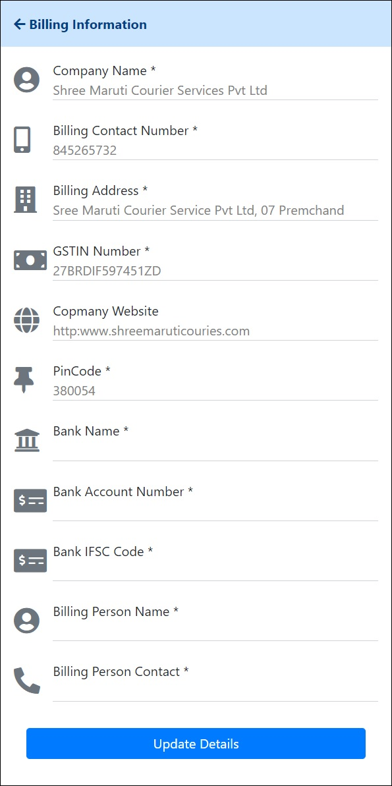
Fig. Billing Information Edit View
- User can also share the billing information by clicking on the sharer billing information button provided on the screen. Once clicked user will be redirected to the User Billing Information Share view screen from where user can share his/her billing information.
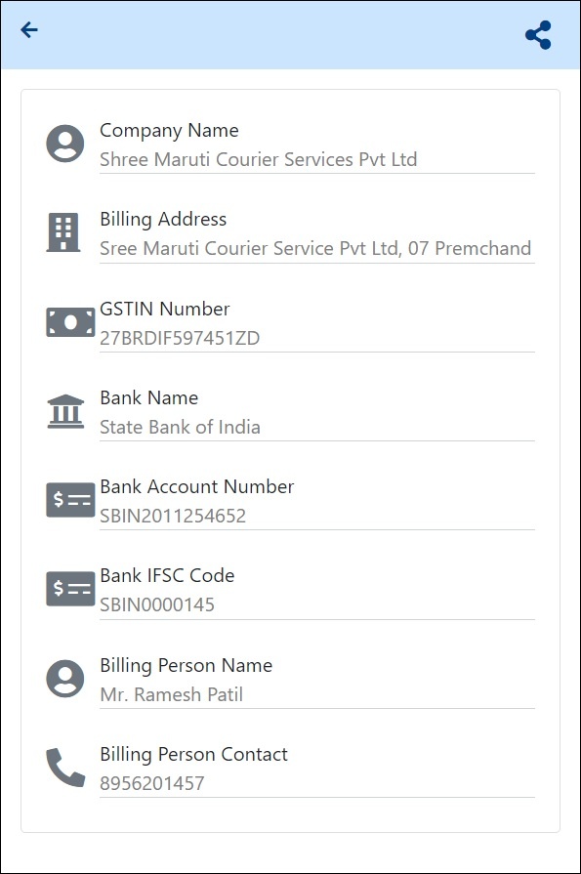
Fig. Billing Information Share View

- User Profile – Manage Company Address
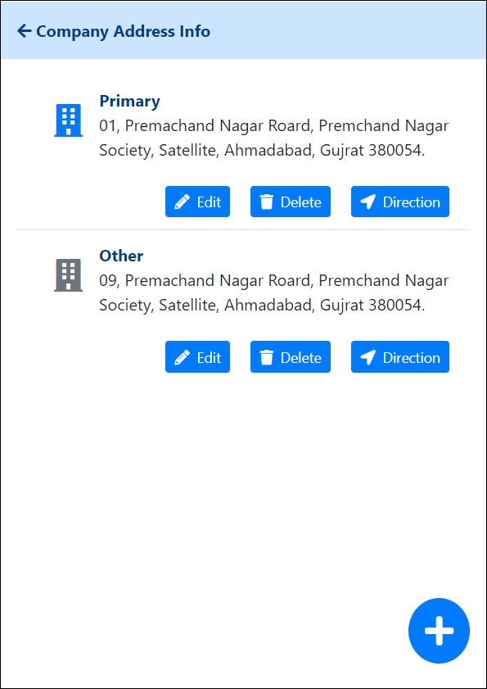
Fig. Manage Company Address
Above figure is showing the Manage Company Address screen when user click on the Manage Company Addresses link in the User Information link section on the User Profile screen.
- User can keep the track of multiple company addresses in the Company Address book details screen. Addresses are categorized in two different types as follows
  - Primary Address
  - Other Address
- User can enter only one primary address in the system and can have multiple other addresses.
- To add new address in the Company, address book user can click on the add address button provided at the bottom right-hand corner of the screen.
- Once Click on the Add Company Address Button Add company address popup window will appear on user screen.
- Company Address book have the following details
- Address *
- City *
- State*
- Country *
- Area *
- Pin code *
- Latitude
- Longitude
- Address Type *
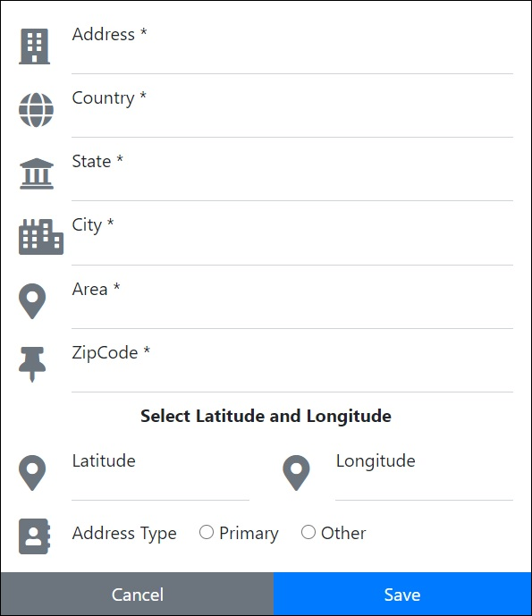
Fig. Add Company Address
- User can close edit the already entered Address by clicking on the Edit button provided for each address details in the company address book.
- When ser click on the Edit button of the Address details following popup window will appear on the user screen.
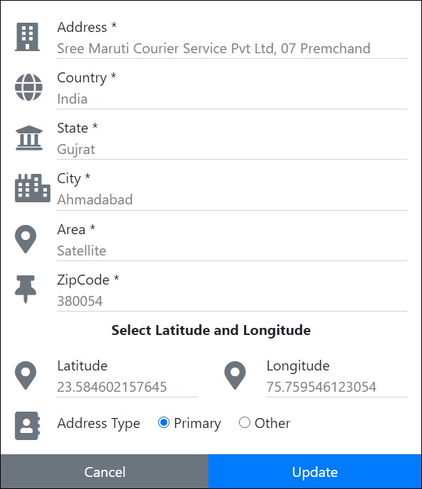
Fig. Edit Company Address
- While entering the company address details latitude and longitude details will be fetched by the system itself by plotting the address provided by the user on google or some other relevant map providing service.
- User can also delete the Address from the company address book by clicking on the Delete company address details button provided for each address.
- When user click on the delete company address button following delete conformation message will appear on user screen.
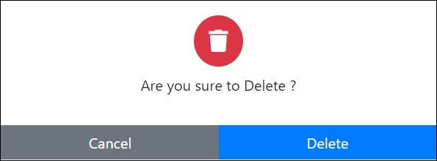
Fig. Delete Company Address Conformation Popup Window

- User Profile – View Product Catalogue
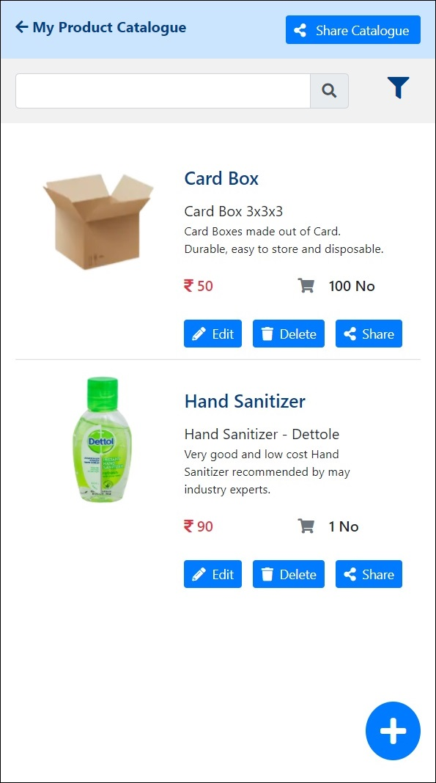
Fig. View Product Catalogue
Above figure is displaying View Product Catalogue screen when user click on the View Product catalogue link in the User Information link section on User profile screen.
- User can view his/her product catalogue on view my product catalogue screen. Following details will be shown about the products in product catalogue
- Product Image
- Product Name
- Product Description
- Other Information
- Product Price
- Minimum Order Qty
- User can perform following activities in the product catalogue
- View Product Detailed View
- Search Product Details
- Add New Product
- Edit Existing Product
- Delete Product Details
- Share Individual Product
- Share entire Product Catalogue
- To view detailed product information user can click on the Product name to navigate on the details view of product information.
Fig. Product Detailed View
- The detailed product detailed view let user know about the in depth. The detailed view of the of product display the following information.
- User can view different product images by using the image slider provided on the screen. For better navigation through images user can user the next and previous button on slider.
- In detailed view User can also view the supplier details for the selected product. Following supplier details will be shown to user
- Supplier Name
- Supplier Mobil No
- Supplier Email Address
- User can search the product detail by entering the product name in the search textbox placed at the top of the screen.
- If user wants in depth search for the product details user can user Advanced Product search facility by clicking the filter menu on the right-hand side of the search textbox.
- A popup winnow will appear on user screen allowing user to user multiple filers to search and view product details. Advance Product search have following filters.
- Product Name
- Keywords
- Business Category
- Business Sub Category
Fig. Advance Product Search
- User can also add new Product in his/her product catalogue by clicking o the Add Product Details button the bottom right-hand corner of the screen as shown in the following figure.
Fig. Add Product Details
- User will be redirected to Add Product screen. User will be entering the following information to Add new Product to product catalogue.
- Product Name *
- Product Description *
- Product Price *
- Product Minimum Quantity and Unit *
- Other Information
- Search Keyword for product *
- Product Primary Image *
- Product secondary Images [Max 04]
- The primary image is mandatory as it will displayed on product catalogue screen and share product details screen. The primary image is placed at top of the screen. The four images at the bottom of it are secondary product images and thus not mandatory.
- User can also Edit the Product details by clicking on the Edit button provide by each product on the view my product catalogue screen. Once user clicked on the Edit Product Details button user will be redirected to Product Details Edit View screen where user can edit and update the product details as shown in following figure.
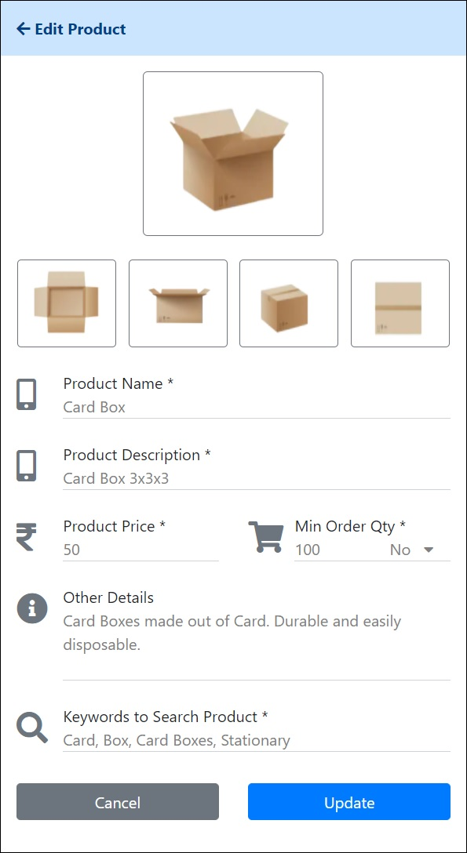
Fig. Edit Product Details
- User can delete the unwanted Product details from product catalogue by clicking on Delete Product Details button provided for each product details in the view my product catalogue screen.
- Once user clicks on the delete product details buttons delete conformation popup window will appear on user screen as shown in following figure.
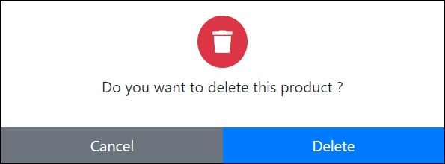
Fig. Delete Conformation Popup Window for Product Detail
- User can Share the product details by clicking on the individua share button provided for each product. When user clicks on the individual product share button, he/she will be redirected to Product Share Details screen as shown in following figure
Fig. Product Details Share Screen
- Also, user can share the entire Product catalogue by clicking on the Share Product Catalogue Button provide on the top right-hand corner of the My Product Catalogue screen.

- Geo Location
- Utility Desk
- Coin Status
- Notification
- Time Line
- Chat

- Custom Notification Matrix
- System will generate the customer notification at various scenarios in the application. The notification will send to user by email, in app notification, through SMS and WhatsApp messages.
- The complete guide of Notification matrix is as follows:

Activity | Action | Notification | Email | SMS | WhatsApp
Comment on Post | New | TRUE | FALSE | FALSE | FALSE
Email Address | Update | FALSE | TRUE | FALSE | FALSE
Mobile Number | Update | FALSE | TRUE | FALSE | FALSE
Post | Delete | FALSE | FALSE | FALSE | FALSE
Post | Dislike | FALSE | FALSE | FALSE | FALSE
Post | Edit | FALSE | FALSE | FALSE | FALSE
Post | Like | TRUE | FALSE | FALSE | FALSE
Post | New | TRUE | FALSE | FALSE | FALSE
User | Follow | TRUE | FALSE | FALSE | FALSE
User | Unfollow | TRUE | FALSE | FALSE | FALSE
Post | Interest | TRUE | TRUE | TRUE | TRUE

Table. User Notification Matrix

